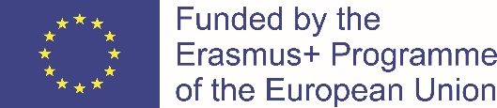

LOGO CONTEST
Erasmus+ KA229 project ,,Together;Stronger” 2020-1-RO01-KA229-079906
Kėdainių specialioji mokykla/Lithuania is responsible for organizing the Logo Contest.
AIMS:
To create the official logo for our Erasmus+KA229 project ,,Together;Stronger”.
RULES:
- Any student of each partner school may participate.
- Each student or a team of students can submit only ONE logo.
- Each school will organise and run by itself the procedure for choosing the logo, which will represent the school in the final selection. Each school will participate with ONE logo only. Each partner school is invited to display the produced logos.
LOGO CHARACTERISTICS:
- The logo can be handmade or it can be made by using a computer programme. They must be original and not similar to existing one or other copyrighted images.
- The logo must contain the name of the project (Together;Stronger) and the name of programme (Erasmus+) and it should also contain references to the countries participating in the project (Romania, Portugal, Turkey, Lithuania, Macedonia).
- To create the logo, the students can use words and/or images.
- The logo must be made on a A4 size of paper, it can be of any shape.
- All partners organize the voting among the students at their schools in order to choose the one best logos.
- The winner will be chosen according to the votes of the partners and it will be announced in the eTwinning (Twinspace) and facebook pages (8 December, 2020). The winning logo will be used in material connected with project.
- The final version of the logo will need to be suitable for printing. The entries must be submitted as a JPG or similar file.
THE CRITERIA:
The criteria for choosing the best design are:
- the logo must illustrate clearly the project;
- the best quality, neatness and innovation will be valued;
- the design must be easy to reproduce on different supports.

DEADLINE:
06.12.2020

